TNE20003 – Internet and Cybersecurity

# **Portfolio Task – Lab 1 Pass Task**

## Aims:

* To build and understand basic network infrastructure
* To build a simple network with Cisco Packet Tracer and observe the data flow within the network

## Preparation:

* View [“Topic 1 – Network Toplogies, Concepts and Protocol”](https://swinburne.instructure.com/courses/54168/pages/topic-1-network-topologies-concepts-and-protocols?module_item_id=3667743)
* Perform tasks instructed in the [Unit Canvas – Packet Tracer](https://swinburne.instructure.com/courses/54168/pages/packet-tracer?module_item_id=3679139).

## Due Date:

* All tasks in this lab are to be completed and demonstrated to your Lab instructor preferably during or at the end of the current lab, but if you do not complete the tasks you may demonstrate it at the beginning of your next lab class.

Task 1.

Build an Understanding of Network Infrastructure

In this task, you will

* record all the different devices attached to the network in your home.
* identify how each device connects to the network to send and receive information.
* create a diagram showing the topology of your network and label each device with its function within the network.

# Instructions

1. Take a close look at the network you have at home.
2. Record the network and end-user devices that are connected on your local home network.

For example,

|  |  |  |  |  |
| --- | --- | --- | --- | --- |
| **Manufacturer** | **Device** | **Location** | **Connection** | **Media** |
| Apple | Iphone 11 Pro | Mobile | Wireless | Wifi & cell phone |
| Apple | Iphone 14 Pro Max | Mobile | Wireless | Wifi |
| Apple | Macbook Pro 2020 | Mobile | Wireless | Wifi |
| ZTE | Wireless Router | Livingroom | Wired | Wifi & Ethernet |
| Samsung | Samsung OLED | Livingroom | Wireless | Wifi |

1. Are there other electronic devices that are not connected to the local network to share information or resources? What would be the benefit of having these devices online?

I have a doorbell device that rings up once when customer come up, an Airpods and a Mega Boom Speaker that only capable to connect via Bluetooth.

-> The benefits of having these devices online could allow the network to enable remote access from distance, data sharing, automation, and integration with other smart devices, enhancing convenience and functionality.

1. Which type of connectivity is used most frequently in your local network, wired or wireless? Explain why.

Mostly, I am using Wireless connection since it is more convinience in terms of devices’ mobility and placement, scalability of range and allow more user to access simultaneously.

1. Draw a diagram of your local network. Label each device with a name and location.

Sample solution shown below

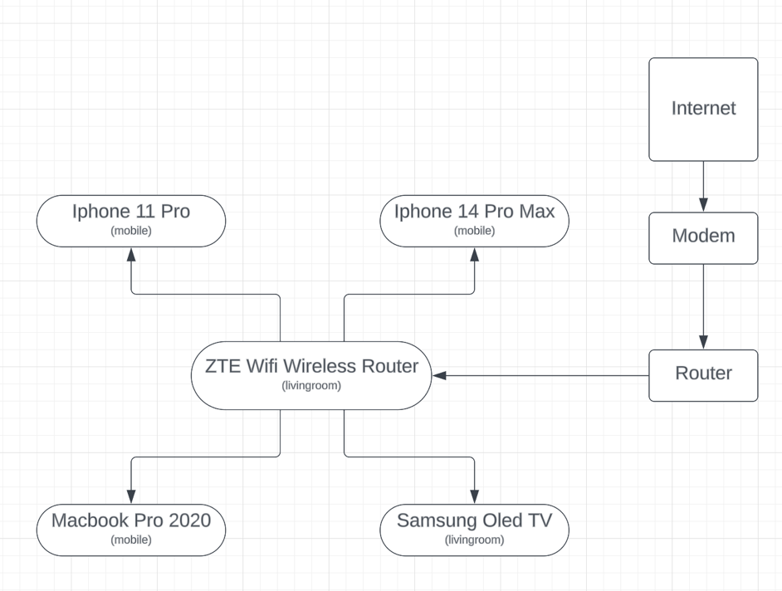

of document

Task 2.

**Build a simple network with Cisco Packet Tracer and observe the data flow within the network**

In this task, you will

* Create/model a simple Ethernet network using 2 PCs, 1 Server, and a Switch.
* Observe traffic behavior on the network.

## Create a logical network diagram with 2 PCs, a Server and a switch.

The bottom left hand corner of the Packet tracer screen displays the icons that represent device categories or groups, such as **Routers**, **Switches**, or **End Devices**.

Moving the cursor over the device categories will show the name of the category in the box. To select a device, first select the device category. When the device category is selected, the options within that category appear in the box next to the category listings. Select the device option that is required.

* + - 1. Select **End Devices** from the options in the bottom left-hand corner. Drag and drop 1 PC and 1 Server onto your design area.
      2. Select **Switch** from the options in the bottom left-hand corner. Add a 2960 switch to your prototype network by dragging it onto your design area.
      3. Select **Connections** from the bottom left-hand corner. Choose a copper straight-through cable type. Click the first PC (PC0) and assign the cable to the **FastEthernet0** connector. Click the switch (Switch0) and select a connection **FastEthernet0/1** for PC0.
      4. Repeat step c for the second PC (PC1) and the Server (Server0). Select **FastEthernet0/2** on the PC1. Select **FastEthernet0/2** on the Server0.

There should be green dots at both ends of each cable connection after the network has converged. If not, double check the cable type selected.

# Configure Host names and IP Addresses on the PC and Server

* + - 1. Click **PC0**. Select the **Config tab**. Change the PC Display Name to **MyPC**. Select **FastEthernet tab** on the left and add **192.168.1.1** as the IP address and **255.255.255.0** as the subnet mask. Close MyPC when done.
      2. Click **Server0**. Select the Config tab. Change the Server Display Name to **FileServer**. Select FastEthernet tab on the left and add **192.168.1.2** as the IP address and **255.255.255.0** as the subnet mask. Close FileServer when done.

You have just builed a simple network as below

# Observe the flow of data from MyPC to FileServer by creating network traffic

* + - 1. Switch to **Simulation Mode** in the bottom right-hand corner.
      2. Click **Edit Filter** in the **Edit List Filter** area. In the event list filter, *only select* **ARP** and **ICMP** filters under IPv4 tab, desect all other filters in the three tabs **IPV4, IPV6** and **Misc**.
      3. Select a **Simple PDU** by clicking the **closed envelope** in the upper toolbar.

With the envelop icon, click **MyPC** to establish the source. Click **FileServer** to establish the destination.

# Note: Notice that two envelopes are now positioned beside MyPC. One envelop is ICMP, while the other is ARP. The Event List in the Simulation Panel will identify exactly which envelop represents ICMP and which represents ARP.

* + - 1. Select **Play** from the Play Controls in the Simulation Panel.

You can speed up the simulation using the Play Speed Slider. The Play Speed Slider is located below Play inside the Simulation Panel. Dragging the button to the right will speed up the simulation, while dragging is to the left will slow down the simulation.

* + - 1. Observe the path ICMP and ARP envelope.

Click **View Previous Event** to continue when the buffer is full.

* + - 1. Click **Reset Simulation** in the Simulation Panel.

Notice that the ARP envelop is no longer present. This has reset the simulation but has not cleared any configuration changes or dynamic table entries, such as ARP table entries. The ARP request is not necessary to complete the ping because MyPC already has the MAC address in the ARP table.

* + - 1. Exit the simulation mode by clicking **Realtime.**

*~~~~~ End of Lab ~~~~~*